**PL/SQL Programming**

**Exercise 1: Control Structures**

**Scenario 1: The bank wants to apply a discount to loan interest rates for customers above 60 years old.**

* **Question:** Write a PL/SQL block that loops through all customers, checks their age, and if they are above 60, apply a 1% discount to their current loan interest rates.
* **Code:**

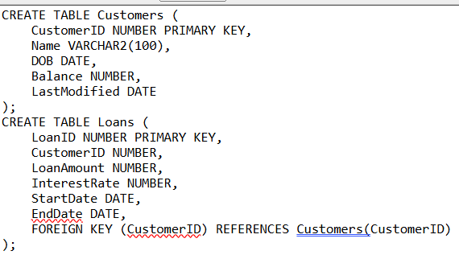

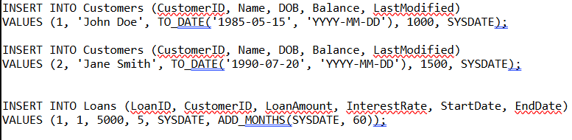

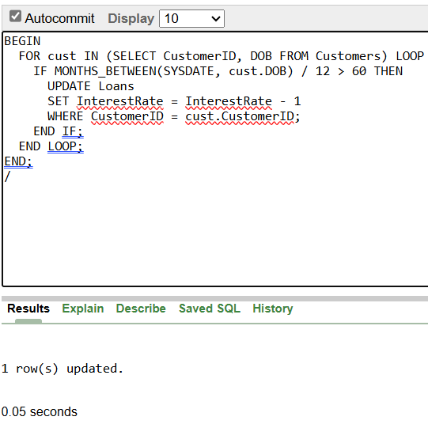

* **Output:**

**----------------------------------------------------------------------------------------------------------------**

**Scenario 2: A customer can be promoted to VIP status based on their balance.**

* **Question:** Write a PL/SQL block that iterates through all customers and sets a flag IsVIP to TRUE for those with a balance over $10,000.
* **Code:**

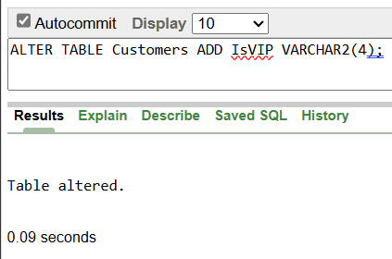

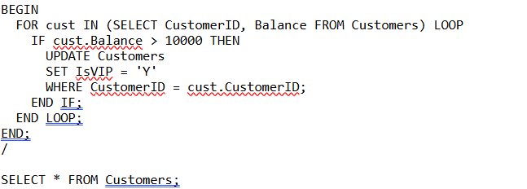

* **Output:**

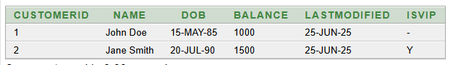

**Scenario 3: The bank wants to send reminders to customers whose loans are due within the next 30 days.**

* **Question:** Write a PL/SQL block that fetches all loans due in the next 30 days and prints a reminder message for each customer.
* **Code:**

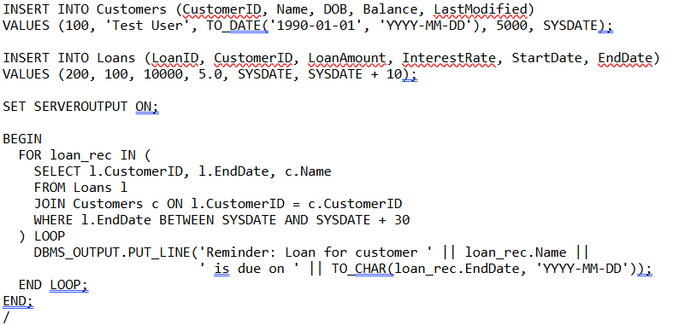

**Output:**

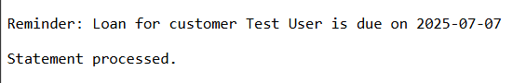

**----------------------------------------------------------------------------------------------------------------**

**Exercise 3: Stored Procedures**

**Scenario 1: The bank needs to process monthly interest for all savings accounts.**

* **Question:** Write a stored procedure **ProcessMonthlyInterest** that calculates and updates the balance of all savings accounts by applying an interest rate of 1% to the current balance.
* **Code:**

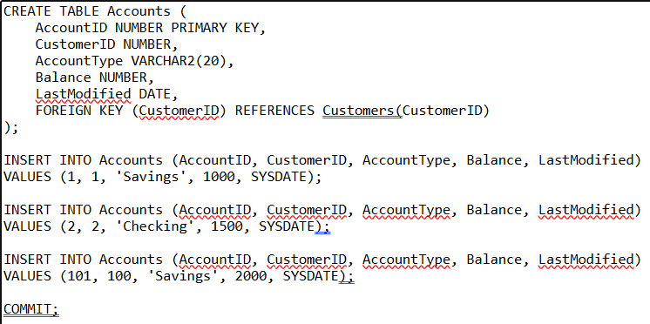

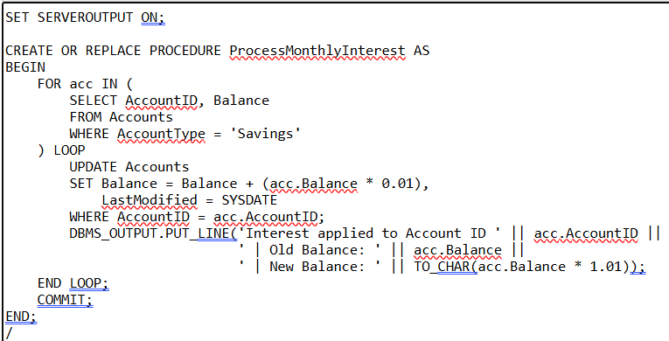

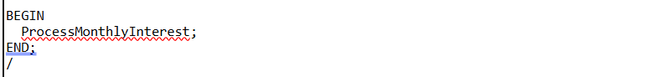

* **Output:**

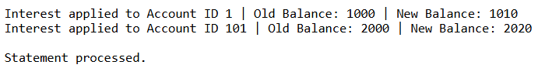

**----------------------------------------------------------------------------------------------------------------**

**Scenario 2: The bank wants to implement a bonus scheme for employees based on their performance.**

* **Question:** Write a stored procedure **UpdateEmployeeBonus** that updates the salary of employees in a given department by adding a bonus percentage passed as a parameter.
* **Code:**

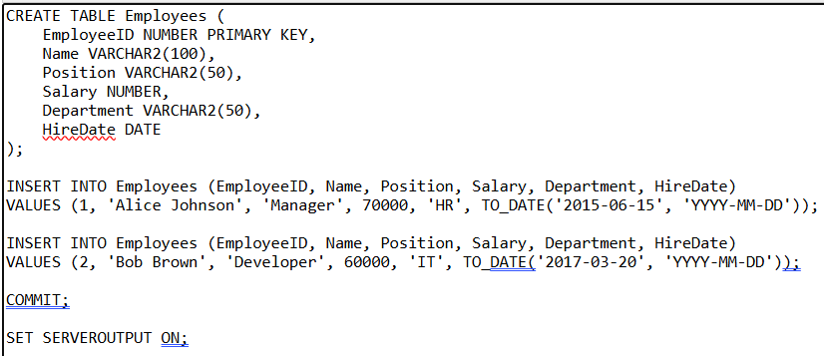

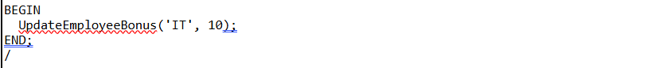

* **Output:**

**-------------------------------------------------------------------------------------------------------**

**Scenario 3: Customers should be able to transfer funds between their accounts.**

* **Question:** Write a stored procedure **TransferFunds** that transfers a specified amount from one account to another, checking that the source account has sufficient balance before making the transfer.
* **Code:**

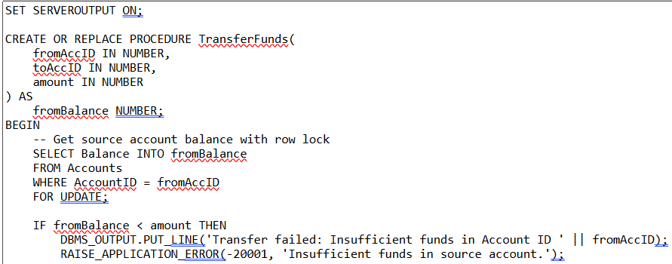

* **Output:**

----------------------------------------------------------------------------------------------------------------